002 NPM - setting up npm & first task

NPM Kata List – Blog Page

[NPM Kata List on GitHub](https://github.com/robertdunaway/katas-npm)

# Duration

10 minutes

# Brief

In this kata we are going to set up a NPM skeleton and create a test task.

### For More Information

BING/GOOGLE: “NPM Getting Started”

# Instructions

Get tutorial folder or the entire katas-npm repo.

Open the [before/*.sln] file and execute the kata.

Feel free to execute this kata multiple times because repetition creates motor memory.

# Github

* Before (start kata with this)
  + <https://github.com/robertdunaway/katas-npm/tree/master/002%20npm%20-%20setting%20up%20npm%20%26%20first%20task/before>
* After
  + <https://github.com/robertdunaway/katas-npm/tree/master/002%20npm%20-%20setting%20up%20npm%20%26%20first%20task/after>

# Kata

In the before solution, create the files and programs necessary to use NPM scripts.

# Review

These katas are demonstrated using Visual Studio 2015 which installs NodeJS so it is assumed Node is installed. If Node is not installed, visit <https://nodejs.org/en/> and install it. NPM is Node’s package manager and we will be using it extensively.

### Create the initial package.json file

Navigate to the root of the solution at the command line and execute the following command.

npm init

Follow the prompts and answer the questions. I kept all the defaults except the name which I called “npm”.

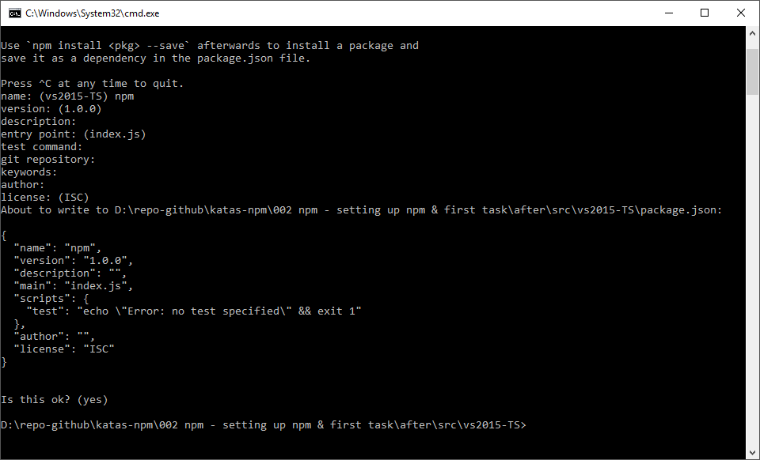

The resulting package.json file.

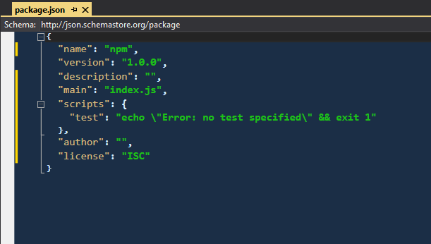

One test script named “test” is preconfigured. Visual Studio is not currently integrated with npm tasks.

Here is what the Task Runner Explorer looks like.

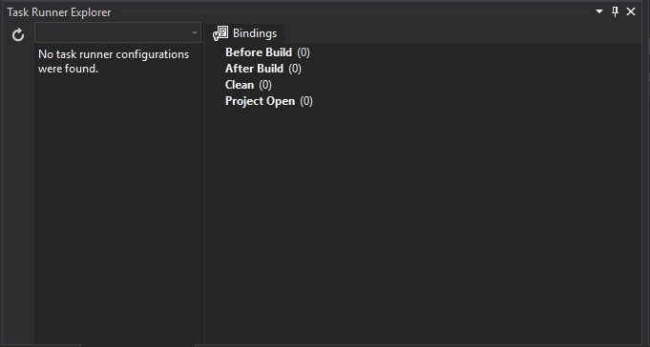

To integrate Visual Studio with NPM tasks install the “NPM Scripts Task Runner” extension.

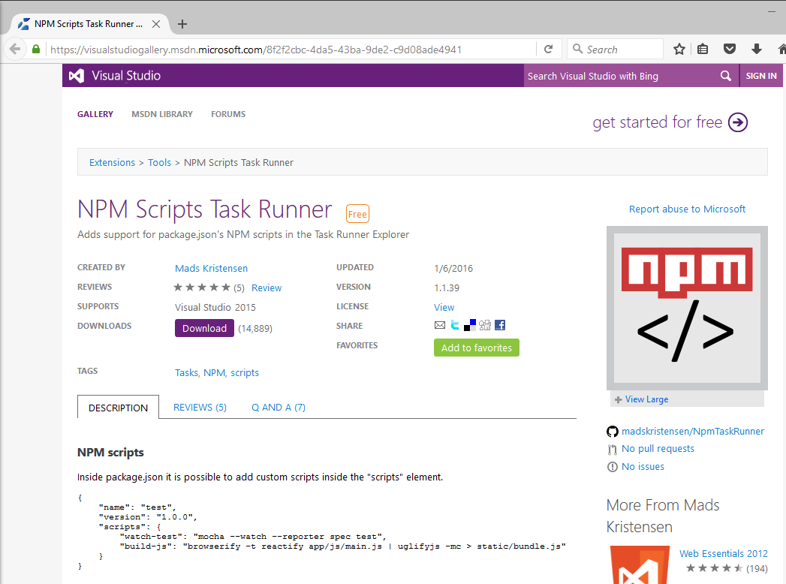

Now you will see NPM scripts in the “Task Runner Explorer”.

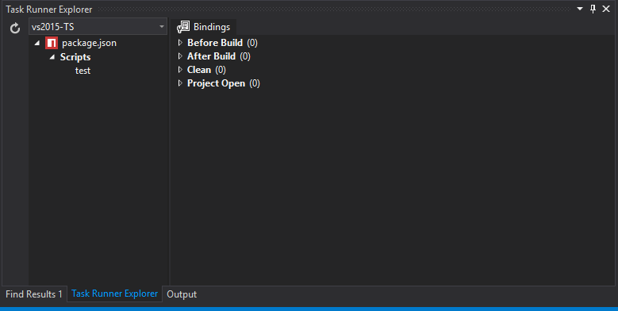

To execute a task right click the task and select “Run”.

Create a new file in the npm-script folder. If you are not using the example project, then you will need to add this folder.

File name: console.js

Add to the contents of the new file

console.log("This is my first NPM script.");

Update the package.json file with a new task that executes the new console.js file.

{

"name": "npm",

"version": "1.0.0",

"description": "",

"main": "index.js",

"scripts": {

"task": "node ./npm-scripts/console.js"

},

"author": "",

"license": "ISC"

}

Right click task and select Run.

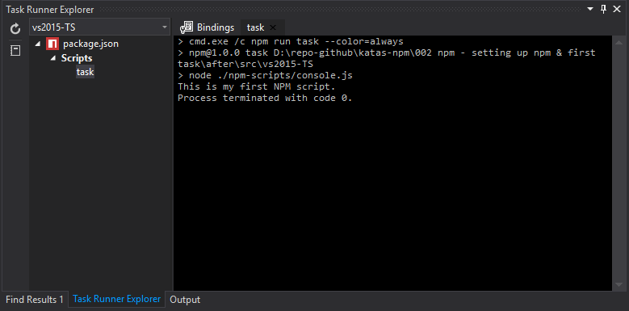

Binding tasks to Visual Studio events.

Right click the “task” task and select Bindings and select Project Open.

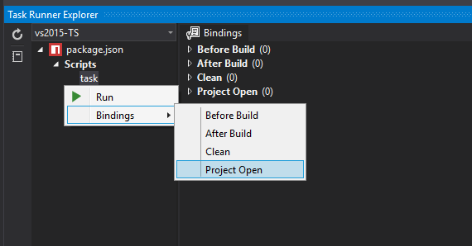

To see if this worked, close Visual Studio and re-open the solution. You’ll see that the task runs.

# Next

Take a few minutes and imagine more examples.